***Practical Marks : 30***

***1.Construct Application for the following Layout***

***(JSP Communications) Marks : 10***

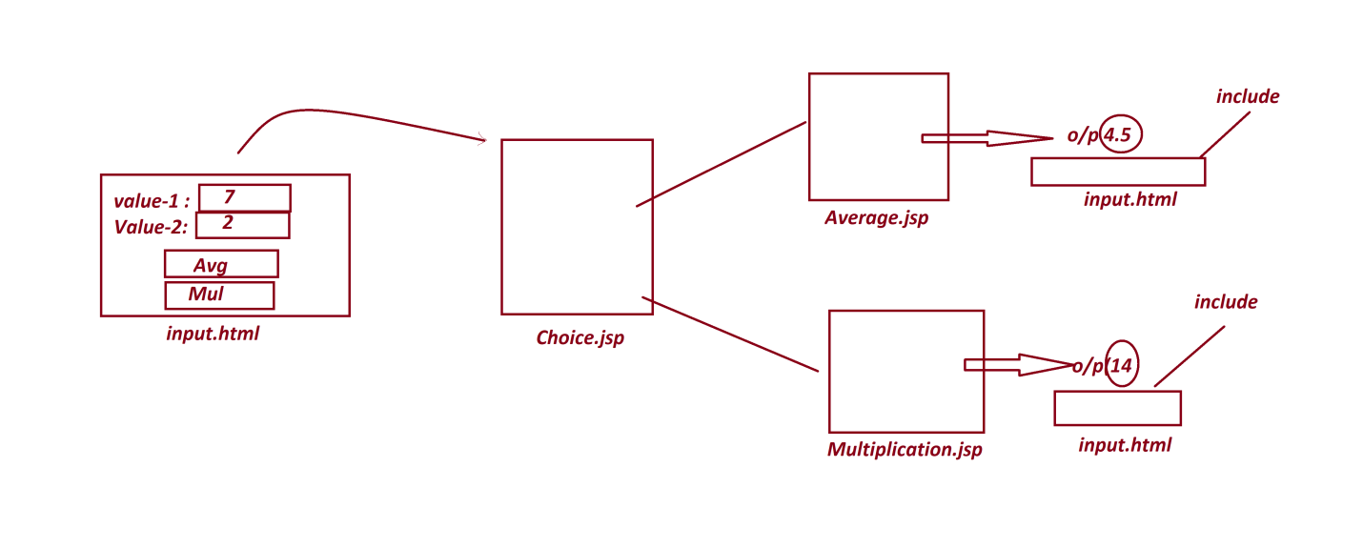

***2.Construct Servlet Application for the following Layout***

***(Login Process using HttpSession) Marks : 20***

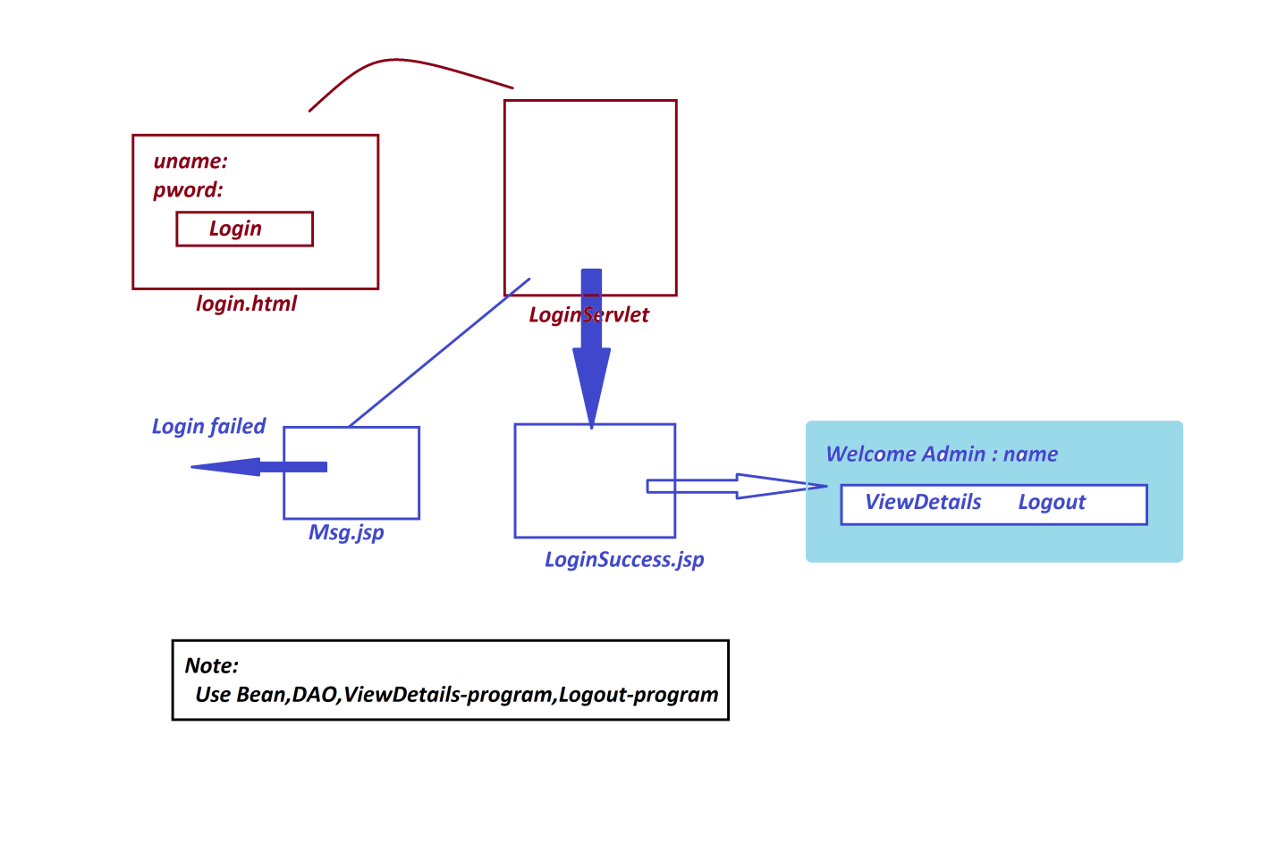

***(Venkatesh Maipathii)***